Vickie,
Thank you so much for agreeing to email these daily reports to me. It is a big help.
Basically, a docket report must run each day and emailed to scott@scottbrenner.com. This is long report and may take 20-30 minutes to create.
- In CMS run the CMSR1231 Report-this is the same report that produces the daily dockets. 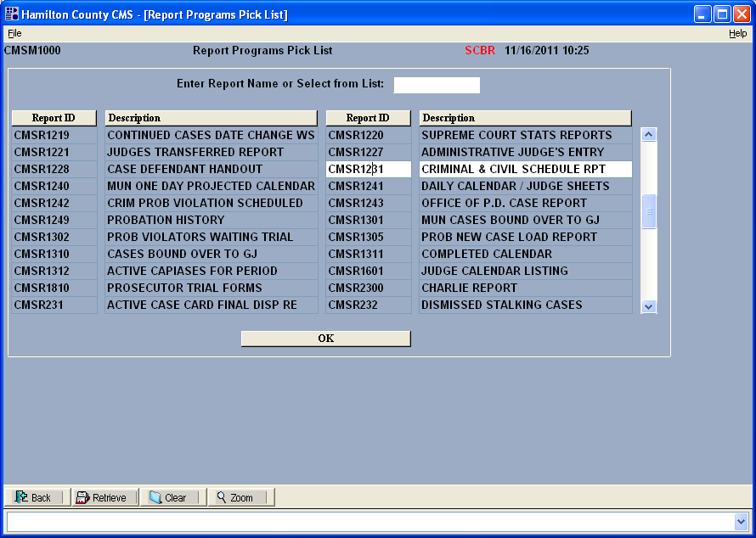
- Set the date range to yesterday through 2018. CMS will take about ten minutes to prepare the report.
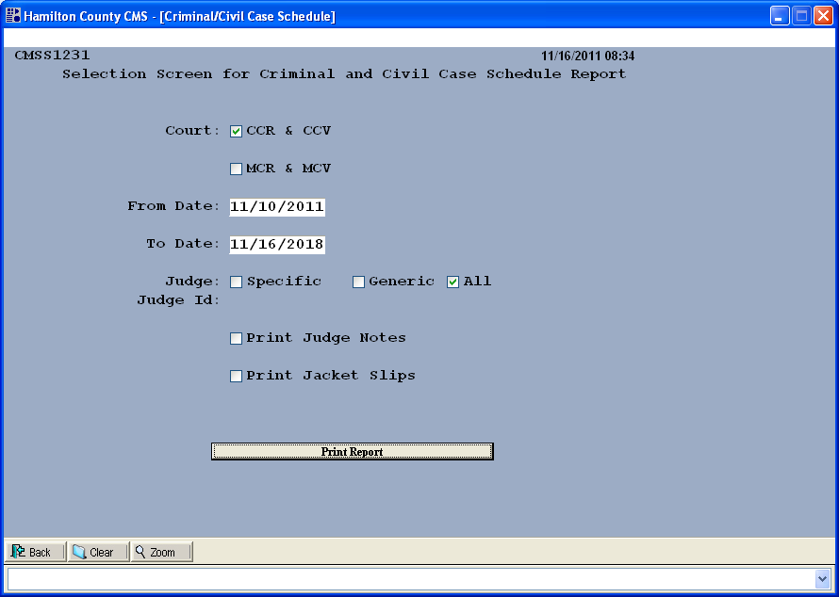
- Once the report is prepared CMS will prompt you to pick a printer. Select PRINT TO WORD PAD(TO SCREEN) and click Print. CMS will take about 20 minutes to print the report. It will NOT print to your printer, instead it will print to a file. 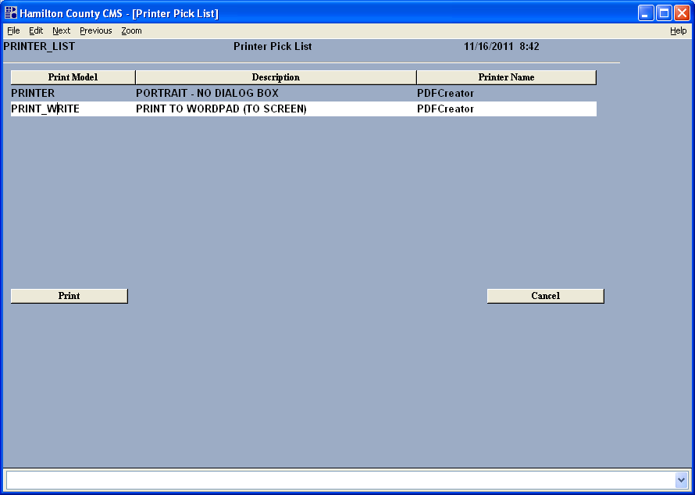
- When CMS finishes printing the report it will open WordPad on your screen. Note the name of the file. It will be something like cmsr1231.Pxx. In the upper left corner of screen capture the name is cmsr1231.P27.
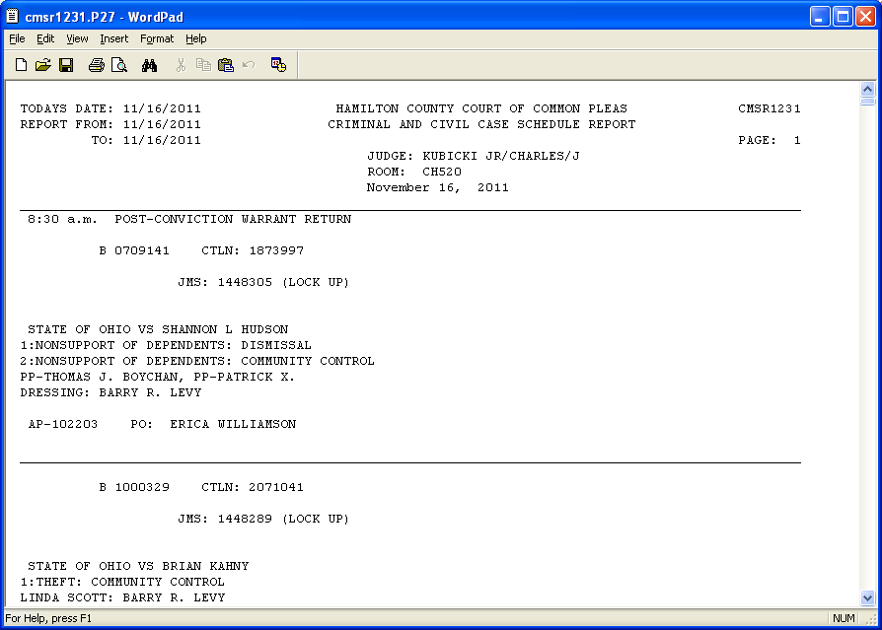
- Email the cmsr1231.Pxx file created in step 4 to scott@scottbrenner.com. The file will be located in C:\CMS.
